LAB 09

Sandeepa Y.V.P

IT24100834

1)

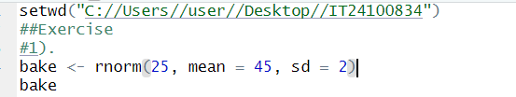

2)

